**ASSIGNMENT 1**

JEMI RAMEESHA J L

Roll.no:232004

Blogspot: <https://www.blogger.com/blog/post/edit/1198243408108742823/5416577675475844883>

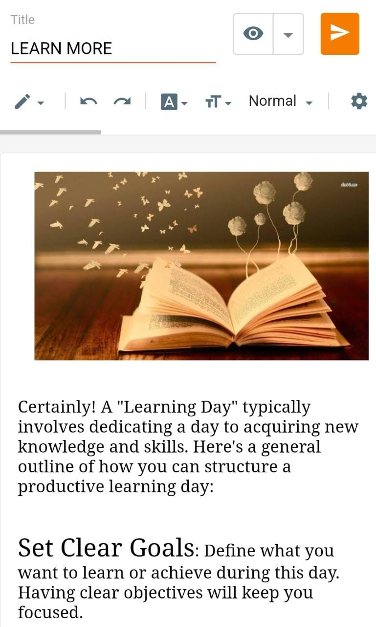

Wordpress: <https://jemirameeshajl8.wordpress.com/2023/10/21/learn-more/>

